By Marina Yurchak
Reading and Writing Activity
a) Look at the picture of the tiger and the boy. What is he wearing? What year is it? How old is he in the picture? How old is he now?
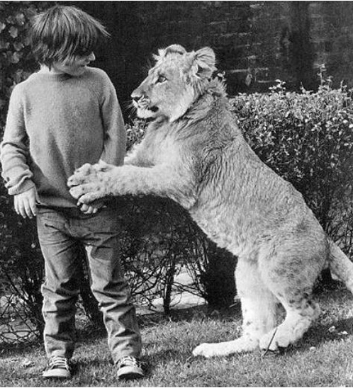
b) Now read the picture story.
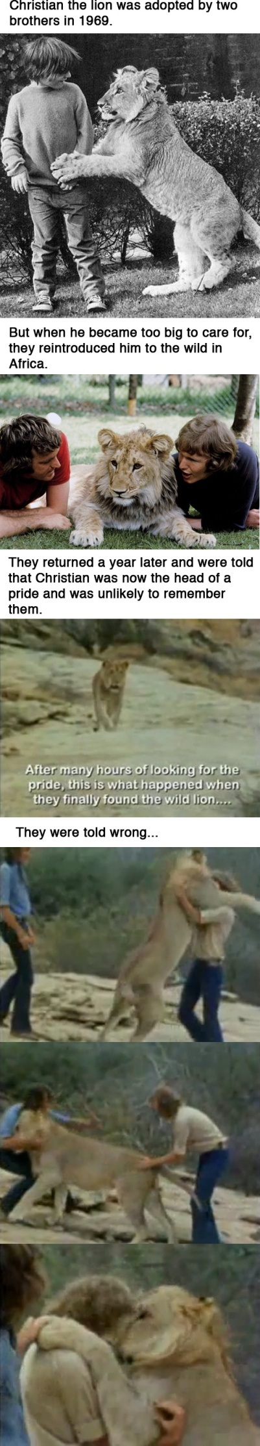
c) Role Play
Student A: You are a one of the brothers (John), tell the reporter about your childhood with the lion cub.
Student B: You are the reporter, ask John about his experience with Christian (the lion). Ask about their meeting in the forest after 20 years.
d) Writing:
Using the given pictures write your own story about the firefighter and the cat. You can use the words in the box:
Fire engine to hold

Firefighter to breathe

Oxygen mask to rescue

Last Friday

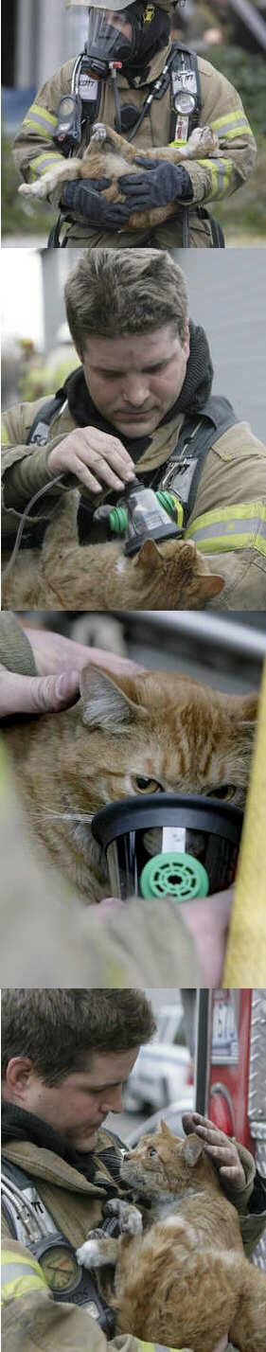
Notes:
The activity is aimed at 5th graders (pre-intermediate or intermediate level). The aim of this activity is to get the children interested in the picture story and thus trigger interest and predict what will happen. After reading the story the students have a chance to roleplay and imagine how they would act in the given situation. And to reinforce the skills the writing task gives them an opportunity to write their own story based on the provided pictures.

