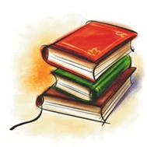
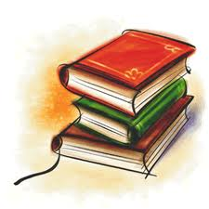
Reading log
Select a book to read. Write the title, author.
After you’ve finished reading it note the genre and the date. If you adandoned it, write A and the date when it was adandoned.
Please not if the book was Easy (E), Just Right (JR) or Challanging (C) for you.
Number | Title | Author | Genre | Date completed | E,  JR,  C

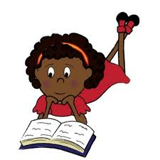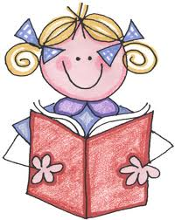
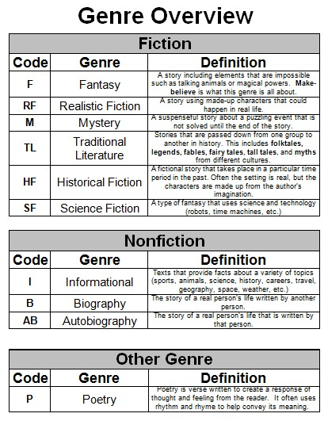
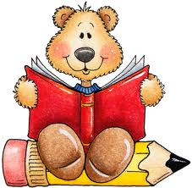
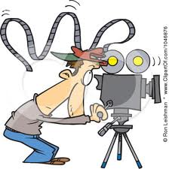
Video task
Choose a film. Answer the following questions about it:
- Title: _____________________________________
- Year: _____________________________________
- Actors: _______________________________________ ______________________________________________
- The plot (what is the film about?) __________________ ________________________________________________________________________________________________________________________________________________________________________________________
- How did the film finish? __________________________ ________________________________________________________________________________________________________________________________________________________________________________________
- Write alternative ending for the film ________________ ______________________________________________________________________________________________________________________________________________________________________________________________________________________________________
- Who is your favourite character? Why? ______________ ________________________________________________________________________________________________________________________________________________________________________________________

- Make a short video (or a video story) about a place that you have recently visited. It can be another city (New York?) or just a new place in your home town (like a zoo or a new swimming pool)
- In your video tell us what the name of the place is. What time of year it is, who you are with and what did you do there. What is so special about this place?
- Would you like to come to this place again?

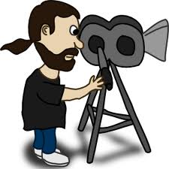
And don’t forget to have fun!

