Prepared by: Marina Yurchak (24.04.2013)
Lesson ‘Seasons’ (with the help of VoiceThread web 2.0 tool)
This activity was prepared for pre-intermediate or intermediate student. The aim is to practice their speaking and listening skills.
At the beginning of the lesson the teacher introduces the topic with the help of the Voicethread prepared by me (https://voicethread.com/#q.b4432184.i0.k0).
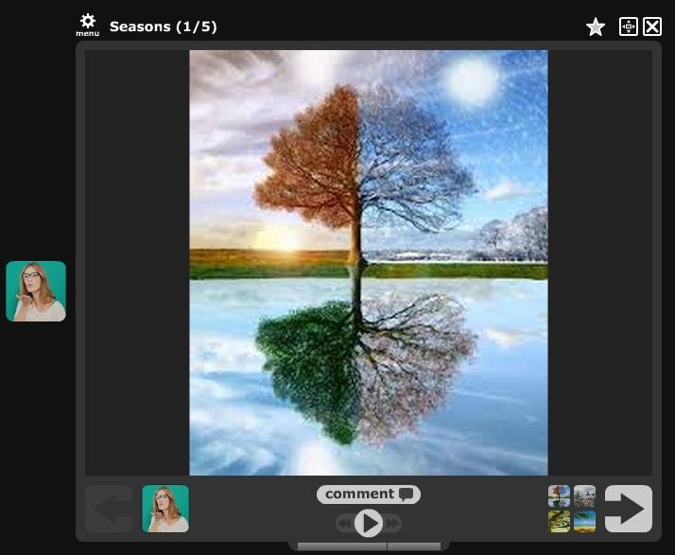
The next step is to help the students register on Voicethread and try to record their answers. Those who prefer not to speak or do not have a microphone available will be asked to use ‘add comment’ button and type the answer.
As a homework activity the students will be asked to initiate their own Voicethread with the topic of their choice.
The following should be included in the homework assignment:
- The Voicethread should have at least 4 slides with a background picture.
- The author should explain why the topic has been chosen.
- The author should also ask questions to the viewers.
- After the Voicethread is finished the student should post the link on the class website (or another tool that their teacher is using to get in touch)
After the Voicethreads have been submitted the teacher might choose to show them in the classroom and ask the students to discuss them in groups. If it is appropriate (depending on the time, how personal the topics are, etc.) the teacher might ask the students to vote for the best Voicethread.
Alternatively the teacher might ask the student to choose 2 of the Voicethreads and answer the authors questions on them. After that, there should be a discussion in the class about their experiences with voicethread.

